**Pet Food Tracker User Manual**

The Pet Food Tracker is a program that lets you input the amount of hay (in oz), pellets (in oz), and treats (in units; 1 treat = 1 unit). The program takes the values you input and keep a running total of what you have used for each. This program also gives a summary of how much of each you used in the last month, as well as the average daily usage of each food item based on the month you select.

**Using the Program**

* Input the month that you want to input the data for using the drop down at the top. This is important for when the program calculates your daily average usage of each food item. Then click the *Set Month* button to confirm.

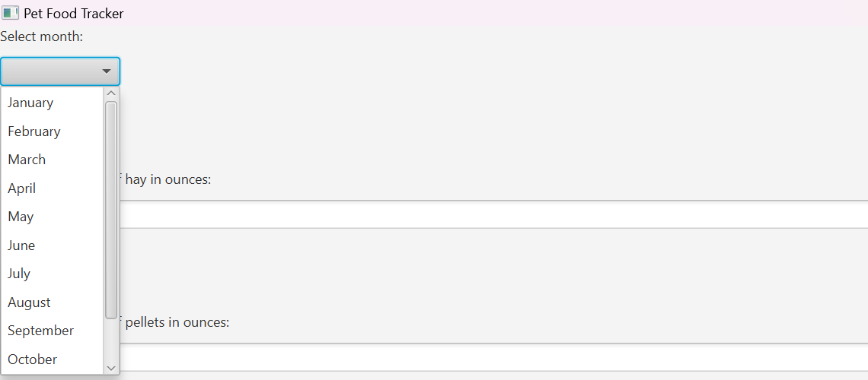

* Next, you can input the amounts of each food item that you want. Hay and pellets are in ounces, treats are in units (# of treats you give). Hay and pellets can be inputted as decimals.

After inputting the amount, click the add button for each. This adds the amount you inputted to the running total (shown later). After submitting, you can keep entering values into the field and adding them as much as you want. The program will tell you if the value was added or not.

* Once you added all of the amounts that you want, you can click on the *View Monthly Summary Button*. This will show the running total of each food item from the previous step, as well as show your daily average for each food item. The daily average is calculated by dividing each running total by the number of days in the month selected earlier.

* Lastly, if you want to reset the values and start over, you can click the *Clear* button.

**Why use this Program?**

This program is useful for keeping track of how much food you are giving your pet in a given month, as well as how much on average you are giving them each day. Knowing these can be useful for knowing how much food you may need to buy each month, as well as comparing your daily average to how much food your pet should be given a day to stay healthy.